**C:\Documents and Settings\julia.powell\My Documents\IHO TSMAD\S100-0 main\IHO S-100 Main Oct 1 2007.doc****© ISO/IEC 2007 – All rights reserved****ISO-IEC_** **63****Complementary element****Introductory element — Main element****Élément introductif — Élément central — Élément complémentaire****Introductory element — Main element — Complementary element****E****2007-10-2****ISO/IEC****ISO/IEC****2007****ISO/IEC****ISO/IEC****_(E).** **2****Heading 2****Heading 1****0****2****STD Version 2.1c2****0** **4****INTERNATIONAL HYDROGRAPHIC ORGANIZATION**



**IHO GUIDELINES** **FOR CREATING S-100 PRODUCT SPECIFICATIONS**

**IHO Publication S-97**

**Edition 1.0.0 – Xxxxxx 2019**

**ART**

**ONTENT**

Published by the

International Hydrographic Organization

4b quai Antoine 1er

Principauté de Monaco

Tel: (377) 93.10.81.00

Fax: (377) 93.10.81.40

E-mail: [info@iho.int](mailto:info@iho.int)

Web: [www.iho.int](http://www.iho.int)

|  |
| --- |
| © Copyright International Hydrographic Organization 2019 |
| This work is copyright. Apart from any use permitted in accordance with the [Berne Convention for the Protection of Literary and Artistic Works](http://www.wipo.int/treaties/en/ip/berne/trtdocs_wo001.html) (1886), and except in the circumstances described below, no part may be translated, reproduced by any process, adapted, communicated or commercially exploited without prior written permission from the International Hydrographic Organization (IHO). Copyright in some of the material in this publication may be owned by another party and permission for the translation and/or reproduction of that material must be obtained from the owner. |
| This document or partial material from this document may be translated, reproduced or distributed for general information, on no more than a cost recovery basis. Copies may not be sold or distributed for profit or gain without prior written agreement of the IHO Secretariat and any other copyright holders. |
| In the event that this document or partial material from this document is reproduced, translated or distributed under the terms described above, the following statements are to be included: |
| *“Material from IHO publication [reference to extract: Title, Edition] is reproduced with the permission of the IHO Secretariat (Permission No ……./…) acting for the International Hydrographic Organization (IHO), which does not accept responsibility for the correctness of the material as reproduced: in case of doubt, the IHO’s authentic text shall prevail. The incorporation of material sourced from IHO shall not be construed as constituting an endorsement by IHO of this product.”* |
| *“This [document/publication] is a translation of IHO [document/publication] [name]. The IHO has not checked this translation and therefore takes no responsibility for its accuracy. In case of doubt the source version of [name] in [language] should be consulted.”*  The IHO Logo or other identifiers shall not be used in any derived product without prior written permission from the IHO Secretariat. |

**Revision History**

Changes to this Specification are coordinated by the IHO S-100 Working Group. New editions will be made available via the IHO web site. Maintenance of the Specification shall conform to IHO Technical Resolution 2/2007 (revised 2010).

|  |  |  |  |
| --- | --- | --- | --- |
| Version Number | Date | Author | Purpose |
| 0.1 | 2018-01-31 | EM, RM | First draft |
| 0.2 | 2018-08-31 | EM, RM | Comments from NIPWG and S-100WG; Multiple updates to conform to S-100 Edition 4.0.0; miscellaneous editorial updates |
|  |  |  |  |
|  |  |  |  |
|  |  |  |  |
|  |  |  |  |
|  |  |  |  |
|  |  |  |  |
|  |  |  |  |
|  |  |  |  |
|  |  |  |  |

Page intentionally left blank

**Contents**

Part A - Content 1

1. Overview 1

1.1. Introduction 1

1.2. References 1

1.3. Terms and Abbreviations 1

2. S-100 Product Specification Template and Its Components 1

**2.1.** **General S-100 Concepts Important to The Readability of The Product Specification** 2

**2.1.1.** **Mandatory Versus Optional Requirements** 2

**2.1.2.** **CamelCase and Its Use In S-100** 2

**2.1.3.** **What are Multiplicities and How Are They Used in S-100** 3

**2.2.** **Main Parts to a S-100 Product Specification** 3

**2.2.1.** **The Overview Section and its Sub-elements.** 3

**2.2.1.1.** **Creation of the Data Product Specification** 3

**2.2.1.2.** **Terms and Definitions** 3

**2.2.1.3.** **Abbreviations** 4

**2.2.1.4.** **Acronyms** 4

**2.2.1.5.** **Informal Data Product Description** 4

**2.2.2.** **Use of Language** 4

**2.2.3.** **Product Specification Maintenance** 4

**2.2.3.1.** **New Edition** 4

**2.2.3.2.** **Revisions** 4

**2.2.3.3.** **Clarification** 5

**2.2.4.** **Version Numbers** 5

**2.2.5.** **Specification Scopes** 5

**2.2.6.** **Dataset Identification** 6

**2.2.7.** **Data Content and Structure** 7

**2.2.7.1.** **Feature Based Data Content Structure** 7

**2.2.7.2.** **Coverage Based Data Content Structure** 8

**2.2.8.** **Data Product Format** 8

**2.2.8.1.** **8211** 8

**2.2.8.2.** **GML** 9

**2.2.8.3.** **HDF5** 10

**2.2.8.4.** **Other Encodings and Encoding profiles** 11

**2.2.9.** **Application Schema** 11

**2.2.9.1.** **Feature Catalogue** 12

**2.2.9.2.** **Model Elements Used in a Product Specification** 12

**2.2.10.** **Reference systems / CRS** 14

**2.2.11.** **Data quality** 14

**2.2.11.1.** **Data quality in the data** 15

**2.2.11.2.** **Data quality checks** 16

**2.2.12.** **Data Capture Instructions** 16

**2.2.13.** **Maintenance** 17

**2.2.13.1.** **Incremental update** 17

**2.2.13.2.** **Whole dataset update** 18

**2.2.13.3.** **Support file maintenance** 18

**2.2.14.** **Data product delivery** 18

**2.2.15.** **Metadata** 19

**2.2.15.1.** **Discovery Metadata** 20

**2.2.15.1.1.** **Discovery metadata for datasets** 21

**2.2.15.1.2.** **Discovery metadata for support files** 21

**2.2.16.** **Portrayal** 21

**2.2.17.** **Additional Information** 22

**3.** **IHO S-100 Infrastructure** 22

**3.1.** **GI Registry** 22

**3.2.** **Feature Catalogue Builder** 23

**3.3.** **DCEG builder** 24

**3.4.** **Portrayal Catalogue Builder** 25

Part A - Content

# **Overview**

This Guideline is intended for developers and maintainers of product specifications based on the IHO framework standard S-100 (Universal Hydrographic Data Model).

Creating an S-100 based Product Specification can be a big challenge for groups with little experience with S-100, especially since S-100 is a comprehensive framework with many details that may need to be considered for any particular Product Specification. A guide to assist development teams through the process can help significantly and decrease the time it takes to create or extend an S-100 based Product Specification.

A core aim of this guideline is to assist in creating harmonized product specifications that can be used in the e-Navigation eco-system. The term e-Navigation eco-system is meant to encompass all product specifications created for use in IMO defined e-Navigation systems, both on shore and at sea, such as ECDIS.

This guideline is intended to serve as a guide for anyone planning to develop or extend an S-100 compliant Product Specification. The guideline consists of three parts:

* Part A (this document)is an in-depth description of the various components of an S-100-based Product Specification;
* Part B (a separate document) describes the typical steps and activities involved in creating an S-100-based Product Specification. Part B describes the overall process, specific activities, and tasks, and includes hints for solving specific problems while the Product Specification is being developed;
* Part C (a separate document) describes the data quality measures deemed appropriate for use in S-100 based product specifications.

# **Introduction**

This guideline is intended to serve as a guide for anyone planning to develop an S-100 compliant Product Specification. The guideline consists of two main parts; Part A (this document) is an in-depth description of the various components of an S-100-based product specification, and Parts B and C (separate documents) describe the typical steps and activities involved in creating an S-100-based product specification; and data quality measures appropriate for an S-100-based Product Specification, respectively. A core aim of this guideline is to assist in creating harmonized product specifications that can be used in the e-Navigation Eco system. The term e-Navigation Eco system in meant to encompass all product specifications created for use in IMO defined e-Navigation systems, both on shore and at sea, such as ECDIS.

# **References**

IHOIB IHO S-100 Information Brochure, May 2017.

ISO 8211 Specification for a data descriptive file for information interchange structure implementations. ISO/IEC 8211, 1994.

ISO 646 Information technology -- ISO 7-bit coded character set for information interchange. ISO/IEC 646, 1991.

ISO 10646 Information technology -- Universal Coded Character Set (UCS). ISO/IEC 10646, 2017.

ISO 19103 Geographic information – Conceptual schema language ISO 19103, 2005.

ISO 19110 Geographic Information – Methodology for feature cataloguing. ISO 19110, 2005.

ISO 19115-1 Geographic information – Metadata – Part 1 – Fundamentals. ISO 19115-1, 2014, as amended by Amendment 1, 2018.

ISO 19136 Geographic information -- Geography Markup Language (GML). ISO 19136, 2007. (Also available as OGC 07-036 Geography Markup Language (GML) Encoding Standard. Open Geospatial Consortium Inc., 2007.)

S-57 IHO Transfer Standard for Digital Hydrographic Data, Edition 3.1 - November 2000

S-58 IHO S-58 ENC Validation Checks, Edition 6.0.0, May 2017.

S-99 IHO S-99 - Operational Procedures for the Organization and Management of the S-100 Geospatial Information Registry, Edition 1.1.0, November 2012.

S-100 IHO S-100 - Universal Hydrographic Data Model, Edition 4.0.0, December 2018.

S-122 IHO S-122 - Marine Protected Areas, Edition 1.0 (draft), August 2017.

S-123 IHO S-123 – Maritime Radio Services, Edition 1.0 (draft), August 2017.

Note: In this document, “S-100” means S-100 Edition 4.0.0 unless a different edition is explicitly identified.

# **Terms and abbreviations**

## **Terms**

abstract class

1. an object class which cannot be **instantiate**d, or is designated in an information model as not allowed to be instantiated
2. NOTE: Subclasses of an abstract class may be either abstract or non-abstract.

aggregation

1. special form of association that specifies a whole-part relationship between the aggregate (whole) and a component part (see **composition**) [ISO 19103]

application

1. manipulation and processing of data in support of user requirements [ISO 19101‑1:2014]

application schema

1. **conceptual schema** for data required by one or more **applications** [ISO 19101‑1:2014]

association

1. semantic relationship between two or more classifiers that specifies connections among their instances [ISO 19103]

attribute

1. (1) named property of an entity [ISO/IEC 2382-17:1999]
2. NOTE: Describes a geometrical, topological, thematic, or other characteristic of an entity.
3. (2) UML: feature within a classifier that describes a range of values that instances of the classifier may hold [ISO/IEC 19501:2005 (Adapted)]
4. (3) XML: name-value pair contained in an element [ISO 19136]

base64

1. an encoding designed to represent arbitrary sequences of octets in a form that allows the use of both upper- and lowercase letters but that need not be human readable [IETF RFC 4648 (restyled)]

code

1. representation of a label according to a specified scheme [ISO 19118:2011]

codelist

1. value domain including a code for a permissible value [ISO 19136]

codespace

1. rule or authority for a code, name, term or category [ISO 19136]
2. EXAMPLE: Examples of codespaces include dictionaries, authorities, codelists, etc.

composition

1. form of aggregation association with strong ownership and coincident lifetime as part of the whole [ISO 19103]

conceptual model

1. **model** that defines concepts of a universe of discourse [19101‑1:2014]

conceptual schema

1. formal description of a **conceptual model** [ISO 19101-1:2014]

data client

1. an end-user receiving encrypted S-100-based data. The data client will be using a software application (for example ECDIS) to perform many of the operations detailed within the S-100 protection scheme [S-100 Part 15 (adapted)]
2. EXAMPLE: An ECDIS user.

data permit

1. file containing encrypted product keys required to decrypt the licensed products, normally created specifically for a particular **data client** [S-100 Part 15 (adapted)]

data server

1. an organization producing encrypted data files or issuing **data permits** to **data clients** [S-100 Part 15, (adapted)]

feature

1. abstraction of real world phenomena [ISO 19101:2003]
2. NOTE: A feature may occur as a type, class, or an instance. Feature type or feature instance should be used when only one is meant. **Feature class** should be used in the context of a model or application schema.
3. EXAMPLE: The phenomenon named 'Eiffel Tower' may be classified with other phenomena into a feature type 'tower'.

feature association

1. **relationship** that links instances of one feature type with instances of the same or a different feature type [ISO 19110]

feature attribute

1. characteristic of a feature [ISO 19101]
2. NOTE: A feature attribute type has a name, a data type and a domain associated to it. A feature attribute instance has an attribute value taken from the value domain of the feature attribute type.
3. EXAMPLE 1: A feature attribute named ‘colour’ may have an attribute value “green” which belongs to the data type “text”.
4. EXAMPLE 2: A feature attribute named ‘length’ may have an attribute value “82.4” which belongs to the data type “real”.

feature catalogue

1. a catalogue containing definitions and descriptions of the **feature types**, **feature attributes**, and **feature associations** occurring in one or more sets of geographic data [ISO 19110]

feature class

1. a class in an **application schema** or **model** that represents a **feature**

feature type

abstraction of real world phenomena [ISO 19101:2003]

1. NOTE: A feature may occur as a type or an instance. Feature type or feature instance should be used when only one is meant.
2. EXAMPLE: The phenomenon named 'Eiffel Tower' may be classified with other phenomena into a feature type 'tower'.

identifier

1. a linguistically independent sequence of characters capable of uniquely and permanently identifying that with which it is associated [adapted from ISO/IEC 11179-3:2003]

information type

1. an identifiable unit of information in a dataset with only thematic attribute properties [S-100 3-5.1.2 (adapted)]
2. EXAMPLE: An information type might be a used to carry a Chart Note.
3. NOTE Information types can also be associated with each other. This could be done where there is further supplementary information that is relevant to the information type or where there is a need to translate the information. For example, a primary information object carrying a Chart Note may contain text in English and an associated supplementary information object may carry the same text in German**.**

instantiate

1. represent by a concrete instance [Merriam-Webster Online <https://www.merriam-webster.com/dictionary/instantiate>]

interface

1. named set of **operations** that characterize the behaviour of an entity [ISO 19119:2005]

metadata

1. information about a **resource** [ISO 19115-1]; data that defines and describes other data [ISO 11179-3:2013]

model

1. abstraction of some aspects of reality [ISO 19109-2015]

operation

1. specification of a transformation or query that an object may be called to execute [ISO 19119:2005]
2. NOTE: An operation has a name and a list of parameters.

register

1. set of files containing identifiers assigned to items with descriptions of the associated items [ISO 19135]
2. NOTE: Descriptions may consist of many types of information, including names, definitions and codes.

registry

1. information system on which a **register** is maintained [ISO 19135]

relationship

1. semantic connection among **model** elements [ISO 19103]

resource

1. identifiable asset or means that fulfils a requirement [ISO 19115-1]
2. EXAMPLES: Dataset, dataset series, service, document, initiative, software, person or organization.

scheme administrator

1. organization solely responsible for maintaining and coordinating the protection scheme specified by S-100 [S-100 Part 15 (adapted)]

service

1. distinct part of the functionality that is provided by an entity through **interfaces** [ISO 19119:2005]

spatial object

1. object used for representing a spatial characteristic of a feature [ISO 19107:2003]

stream

1. in online data exchange: a continuous sequence of fragmented data to be transported by a communication system [S-100]

universe of discourse

1. view of the real or hypothetical world that includes everything of interest [19101‑1:2014]

vocabulary

1. terminological dictionary which contains designations and definitions from one or more specific subject fields [ISO 1087-1:2000]

## **Abbreviations**

AIS Automatic Identification System

DQWG Data Quality Working Group

ECDIS Electronic Chart Display and Information System

ENC Electronic Navigational Chart

GML Geography Markup Language

GFM General Feature Model

GI registry Geospatial Information registry

HDF Hierarchical Data Format

HTTP Hypertext Transfer Protocol

HTTPS HTTP Secure

IALA International Association of Lighthouse Authorities

IEC International Electrotechnical Commission

IHO International Hydrographic Organization

IMO International Maritime Organization

ISO International Organization for Standardization

RENC Regional ENC Coordinating Centre

REST Representational State Transfer

SENC System Electronic Navigational Chart

SOAP Simple Object Access Protocol

SoS Sensor Observation Service

SSL Secure Sockets Layer

TCP/IP Transmission Control Protocol/ Internet Protocol

VTS Vessel Traffic Service

WSDL Web Services Description Language

WFS Web Feature Service

XML eXtensible Markup Language

XSD XML Schema Definition

# **S-100 product specification template and its components**

A data Product Specification is a precise technical description which defines a geospatial data product. It describes all the features, attributes and relationships of a given application and their mapping to a dataset. It includes general information for data identification as well as information for data content and structure, reference system, data quality aspects, data capture, portrayal, maintenance, delivery and metadata. It may be created and used on different occasions, by various parties and for various purposes.

Part 11 of S-100 describes data product specifications for geographic data products. Its aim is to provide a clear and similar structure for any data product specification to be written. A Product Specification shall constitute a set of human readable documentation. Generally, it should also include machine readable files for information such as the Feature Catalogue, the Application Schema and the CRS parameters. An example of a compliant Product Specification is shown in Appendix 11-B of S-100. In addition to a ‘human readable’ document, it is possible to create a machine readable (for example XML) summary of the Product Specification, which can be an XML document of the tables found in Part 11 of S-100.

## **General S-100 concepts important to the readability of the product specification**

## **Mandatory versus optional requirements**

For a product specification to claim compliance with S-100, some specific parts are required. For example, it is required to include a Feature Catalogue, while a Portrayal Catalogue is optional. Tables in S-100 Part 11 indicate what is mandatory and what is optional by the multiplicity column in each table. Table 5‑1 below is an example of such a table.

|  |  |  |  |
| --- | --- | --- | --- |
| **Name** | **Description** | **Multi** | **Type** |
| title | Official designation of the data product | 1 | CharacterString |
| abstract | Informal description of the data product | 1 | CharacterString |
| acronym | Any acronyms for the title of the data product | 0..* | CharacterString |
| content | Textual description of the content of any dataset which conform to the specification | 1 | CharacterString |
| spatialExtent | Description of the spatial extent covered by the data product | 1 | EX_Extent (ISO 19115-1) |
| temporalExtent | Description of the temporal extent covered by the data product | 0..1 | EX_Extent (ISO 19115-1) |
| specificPurpose | Specific purpose for which the data shall be or has been collected | 1 | CharacterString |

Table 5‑1 - Example of S-100 table (Informal Description of the Data Product, S-100 Table 11-1)

In the above example, the Multi (short for “Multiplicity”) column indicates which elements are mandatory and which are optional. The rows title, abstract, content, spatial extent and specific purpose are all mandatory, as indicated by the multiplicity of 1, while the rows acronym and temporal extent are optional, as indicated by the multiplicities of 0..* and 0..1.

## **CamelCase and its use in S-100**

S-100 uses camelCase extensively, and the use is based on principles inherited from ISO 19103. Camel case (stylized as camelCase or CamelCase; also known as camel caps or more formally as medial capitals) is the practice of writing compound words or phrases such that each word or abbreviation in the middle of the phrase begins with a capital letter, with no intervening spaces or punctuation. Common examples include "iPhone ", "eBay", "FedEx", "DreamWorks", "HarperCollins", "iCarly", "WordWorld", and "WordGirl". It is also sometimes used in online usernames such as "JohnSmith", and to make multi-word domain names more legible, for example in advertisements [Wikipedia, 2017]. S-100 makes use of camelCase as a method to construct distinct identifiers or names of elements used within S-100 itself, within the GI Registry, Feature Catalogues, etc.

The camelCaseIdentifier must according to S-100 clause 2a-4.2.3:

* Be compound words in which the words are joined without spaces and are capitalized within the compound.
* Be unique within the registry.
* Conform to ISO 10646[1] with uppercase characters A-Z, 0-9, ”_”, and lowercase characters a-z.
* Features and Information types must begin with uppercase A-Z.
* Attributes and enumerated values must begin with lowercase a-z.

EXAMPLE 1: BeaconCardinal is the Camel Case identifier for the feature Beacon Cardinal

EXAMPLE 2: categoryOfLandmark is the Camel Case identifier for the attribute Category of Landmark

## **What are multiplicities and how are they used in S-100**

Within the tables, models and other parts of S-100, the concept of multiplicity is used to give the number of repetitions of a particular entity in the given context, such as how many times an attribute can be used within a class. More details can be found in S-100 Part 1-4.5.3.3 – S100_Multiplicity, and subsequent paragraphs.

## **Main parts of an S-100 Product Specification**

This section gives a highlight of the parts that make up an S-100 Product Specification, and elaborates on why these parts are needed.

## **The overview section and its sub-elements.**

The Overview section of a Product Specification provides a reader with general introductory information about the data product together with Product Specification metadata. S-100 states that the Overview shall include the following parts:

* Introduction
* References
* Terms, definitions and abbreviations
  + Use of Language
  + Terms and Definitions
  + Abbreviations
* General Data Product Description
* Data product specification metadata
* Product Specification Maintenance

The next paragraphs elaborate on each of these parts and their intended use.

## **Introduction**

This section gives information about the creation of the Product Specification, which shall include the title, a reference date, the responsible party and the language of the document, normally English. Additionally, information about the maintenance regime for the Product Specification should also be included. This can be a statement about a periodic review and update of the specification, or that it will be updated on an as needed bases, and so forth.

## **Terms and definitions**

A section of terms and definitions, which are used within a Product Specification. These are often useful references for the reader, and should reflect the content of the specification as well as the context it is intended to be used in.

## **Abbreviations**

Any abbreviations used in the specification should be listed with their full meaning in a separate abbreviations section within the introductory parts of the Product Specification.

## **Acronyms**

It is customary to give an acronym for the name of the data product, for example AML (Additional Military Layer), or ENC (Electronic Navigational Chart), these can be stated in the data product identification section of the Product Specification. Acronyms may also be used throughout the specification for a variety of reasons, these should be collected in an acronym paragraph at the beginning of the document to serve as a quick reference for the reader.

## **General data product description**

An informal description of the data product, which can read like an abstract of the specification, its purpose and intended use context. See also section 2.2.6.

## **Use of language**

Although optional, it can be beneficial to add a Use of Language section to elaborate the intended meaning of specific words used within the Product Specification documentation, including appendices and annexes. The purpose is to remove as much ambiguity as possible regarding these words so that the specification is clear regarding what is a mandatory requirement, what is highly recommended and what is optional. In this regard, the following statements have been used frequently within IHO specifications:

* “Must” indicates a mandatory requirement.
* “Should” indicates an optional requirement, that is the recommended process to be followed, but is not mandatory.
* “May” means “allowed to” or “could possibly”, and is not mandatory.

## **Product specification maintenance**

Changes to a Product Specification issued by the IHO will be released as a New Edition, a Revision, or as a document that includes Clarifications. Which level is used depends on the nature of the change. It is likely that other issuing authorities will follow IHO’s example. Generally, this text follows the guidance given in S-100 Part 12, where three types of change are described; New Edition, Revision and Clarification. These change types are elaborated in a general manner below. Minor variations to these can be expected depending on the type of product specification.

## **New Editions**

New Editions introduce significant changes. New Editions enable new concepts, such as the ability to support new functions or applications, or the introduction of new constructs or data types. New Editions are likely to have a significant impact on either existing users or future users of a Product Specification.

## **Revisions**

Revisions are defined as substantive semantic changes. Typically, Revisions will introduce changes to correct factual errors or introduce necessary changes that have become evident as a result of practical experience or changing circumstances. A Revision must not also be classified as a Clarification. Revisions could have an impact on either existing users or future users of the specification. All accumulated Clarifications will be included with the release of approved Revisions.

Changes in a Revision ensure backward compatibility with the previous versions within the same Edition. Newer Revisions, for example, introduce new features and attributes. Within the same Edition, a dataset of one version could always be processed with a later version of the feature and portrayal catalogues. In most cases a new feature or portrayal catalogue will result in a Revision of this specification.

## **Clarifications**

Clarifications are non-substantive changes. Typically, Clarifications: remove ambiguity; correct grammatical and spelling errors; amend or update cross references; insert improved graphics, spelling, punctuation and grammar. Clarifications must not cause any substantive semantic changes.

Changes in a Clarification are minor and ensure backward compatibility with the previous versions within the same Edition. Within the same Edition, a dataset of one Clarification version could always be processed with a later version of the feature and portrayal catalogues, and a Portrayal Catalogue can always rely on earlier versions of the Feature Catalogues.

## **Version numbers**

The associated version control numbering to identify changes (n) in S-100 and derived specifications generally follow this format:

New Editions denoted as n.0.0

Revisions denoted as n.n.0

Clarifications denoted as n.n.n

The same format for versioning has also being adopted for most of IHO’s other Standards.

## **Specification scopes**

Some parts of a Product Specification may apply to the whole product whereas other parts of the Product Specification may apply to parts of the product. For example, a coordinate reference system will generally apply to the complete product, while maintenance regimes may be different for navigational features versus contextual features. This difference would be described using scopes which state what parts of a specification are global and which parts are specific to a portion of the specification. When this is the case for a product being specified, the specification scopes section defines the various “scopes” within the overall Product Specification, and how they should be identified in the datasets. Depending on the type of Product Specification, the scope may include items in Table 5‑2.

|  |  |  |  |
| --- | --- | --- | --- |
| **Name** | **Description** | **Mult** | **Type** |
| scopeIdentification | Specific identification of the scope | 1 | CharacterString |
| Level | Hierarchical level of the data specified by the scope | 0..1 | MD_ScopeCode (ISO 19115-1) |
| levelName | Name of the hierarchy level | 0..1 | CharacterString |
| levelDescription | Detailed description about the level of the data specified by the scope | 0..1 | CharacterString |
| Coverage | Subtype of a feature that represents real world phenomena as a set of attributes | 0..1 | CharacterString |
| Extent | Spatial, vertical and temporal extent of the data | 0..1 | EX_Extent (ISO 19115-1) |

Table 5‑2 - Specification Scope Information (S-100 Table 11-3)

If a specification is homogeneous across the whole data product it is only necessary to define a general scope (root scope), to which each section of the Product Specification applies. This general scope may look something like the following example:

Scope identification: Global scope  
Level: 006- series

Level name: Dataset

Level description: Level applies globally to all ENC datasets

Coverage: All features in the ENC feature catalogue

Extent: EX_GeographicBoundingBox

westBoundLongitude: -180

eastBoundLongitude: 180

southBoundLatitude: -90

northBoundLatitude: 90

The Level attribute is a codelist found in ISO 19115-1 called MD_ScopeCode comprising the major components of a specification. The Extent attribute is a class that can be any combination of the following: description string; a geographical extent (like in the example above); vertical extent; or temporal extent.

The Product Specification may specify a partitioning of the data content of the product on the basis of one or more criteria. Such partitioning may be different for different parts of the Product Specification. Each such part of the data content shall be described by a specification scope that may inherit or override the general scope specification. In principle, any or all of the remaining sections of the Product Specification may have variants which apply to the scopes within the product. Each variant must identify the scope(s) to which it applies.

EXAMPLE: Data products to support navigation often contain two sets of feature types: those that provide navigation information that changes rapidly and which presence is essential for safety of navigation; and those that provide background reference information. Maintenance and delivery information would be partitioned on the basis of these groupings; essential information would be maintained and delivered whereas reference system information would not.

## **Dataset identification**

In addition to the informal description of the data product (see also section 5.2.1.4), S-100 also calls for a section that describes information that uniquely identifies any dataset as being created in accordance with a specific Product Specification series.

Different from the general information about the data product, the dataset identification is for the individual dataset. It is possible to standardize some of the elements if that is beneficial. For example, the Purpose attribute value may be common among all datasets created from a particular specification. Other attributes may benefit from following a common schema, such as the Dataset Title may follow a particular style that users are familiar with. Some of the attributes are codelist types defined elsewhere, such as in ISO 19115-1, these attributes are limited to the values given in those codelists. There may be cases where it is beneficial to restrict the given codelists to a subset of values, if for example not all values make sense for the scope of the specification.

This information is stored in the metadata that is associated with the dataset. Therefore, it is important to ensure that appropriate metadata attributes are available, and to harmonize this section with the metadata section.

Some product specifications have merged the informal description of the data product with the dataset identification section, into a common section. This is an allowed option.

## **Data content and structure**

The data content and structure of products created from an S-100 Product Specification is defined in an Application Schema. Application schemas are fundamental elements of any S-100 based Product Specification. The General Feature Model of S-100 (Part 3) specifies the rules for developing an Application Schema which includes the conceptual model for features and their characteristics and associations.

## **Feature based data content structure**

The data content of a geographic application is defined in accordance with a view of real world features and in the context of the requirements of a particular application. The content is structured in terms of objects. S-100 considers two types of object, which are defined in Part 3 clause 5.1. To elaborate on the definition in S-100, the following explanations can help.

1. Features – features are defined together with their properties. A feature is an abstract representation of real world phenomenon. Features have two aspects; feature type and feature instance. A feature type is a class and is defined in a Feature Catalogue. A feature instance is a single occurrence of the feature type and represented as an object in a data set.
2. Information – information types are used to share information among features and other information types. An information type is a class of object which is defined in a Feature Catalogue. An instance of an information type is an identifiable unit of information in a data set. Information types have only thematic attribute properties. An instance of an information type may be associated with one or more feature instances or one or more instances of other information types. Information types can be thought of as shared attributes.

The General Feature Model (GFM) provides a conceptual model for these objects. The definitions for object types are held in a Feature Catalogue. The GFM also acts as a conceptual model for the Feature Catalogue. Spatial information is defined in S-100 Part 7, Spatial Schema, and consists of simple geometry which can be expressed in multiple configurations. The Application Schema must define the spatial components used in a Product Specification and the relationship to the feature classes.

## **Coverage based data content structure**

Although the conventional approach is to consider an image or a grid as a unique entity on its own, and to not consider a feature structure, it is proper to consider imagery, gridded and coverage data as feature-oriented data. In the simplest form, an image or any set of gridded data can be considered as a single feature. Thus, rules for Application Schema for feature data apply to imagery and gridded data as well. However, care must be taken to ensure that the Application Schema accurately defines the Imagery and Gridded Data Spatial Schema in accordance with S-100 Part 8, clause 8-6; and the Gridded Data Spatial Referencing as defined in clause 8-8. If the product contains a series or set of images or gridded data sets, then the Application Schema defining the spatial relationships should be defined as specified in S-100 Part 8, clause 8-7.

## **Data product format**

S-100 based product specifications shall define the format (encoding) in which each scope within the data product is delivered. This includes a description of file structures and formats where applicable; or the format of a data stream if so applicable. The encoding structure could be specified completely in the specification, or by reference to a separate profile or standard. S-100 includes profiles of three encodings: ISO 8211 binary encoding; GML (ISO 19136) encoding; and HDF5 encoding. These profiles can be referenced by a Product Specification along with a description of how to use them within the specific Product Specification. For example, a given product would have a specific GML application schema, expressed in one or more XML Schema Definition Language files.

Specialized products may use other encodings by specifying the whole encoding within the Product Specification (or by referencing an established external standard, or an appropriate combination of the two). It should be noted that in such cases, implementation costs may be higher than for systems using the standard S-100 encodings.

A brief description of the S-100 profiled encodings is provided in the following clauses.

## **ISO 8211**

The ISO/IEC 8211 Specification is a data descriptive file format for information interchange. S-100 Part 10a specifies the structure of an exchange set at the record and field levels. It further specifies the contents of the physical constructs required for their implementation as ISO/IEC 8211 data records, fields, and subfields. The grouping of records into ISO/IEC 8211 files is considered application specific and is, therefore, necessary to be described in the relevant Product Specification. In S-100 only the binary ISO/IEC 8211 format is used.

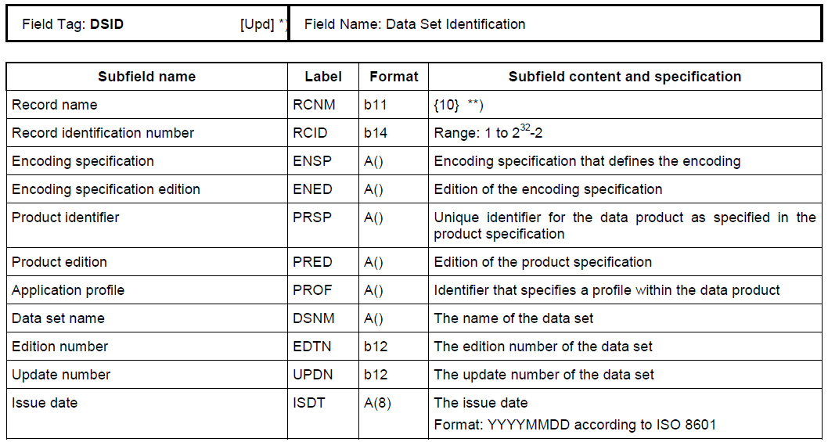

Figure 5‑1 - Example of Field Tables

## **GML**

The Geography Markup Language (GML) is an XML grammar defined by the Open Geospatial Consortium (OGC)/ISO 19136 to express geographical features. GML serves as a modelling language for geographic systems as well as an open interchange format for geographic transactions on the Internet. It should be noted that the concept of feature in GML is a very general one and includes not only conventional "vector" or discrete objects, but also coverages and sensor data. The ability to integrate all forms of geographic information is the key to the utility of GML.

S-100 Part 10b specifies a profile of GML meant to be used as a basis for the development of GML application schemas for S-100 based data products. The GML Application Schema for each data product defines a file format for the machine-to-machine exchange of information structured in conformance with the Application Schema for the data product, as defined in the appropriate Product Specification.

The S-100 GML profile defines the core GML components that shall be used in GML encodings for S-100 based data products. This profile defines a restricted subset of XML and GML types that excludes GML features not required by S-100 GML datasets. This subset of GML is then used to create the specific GML encoding for a product specification. This approach is described in Figure 5‑2.

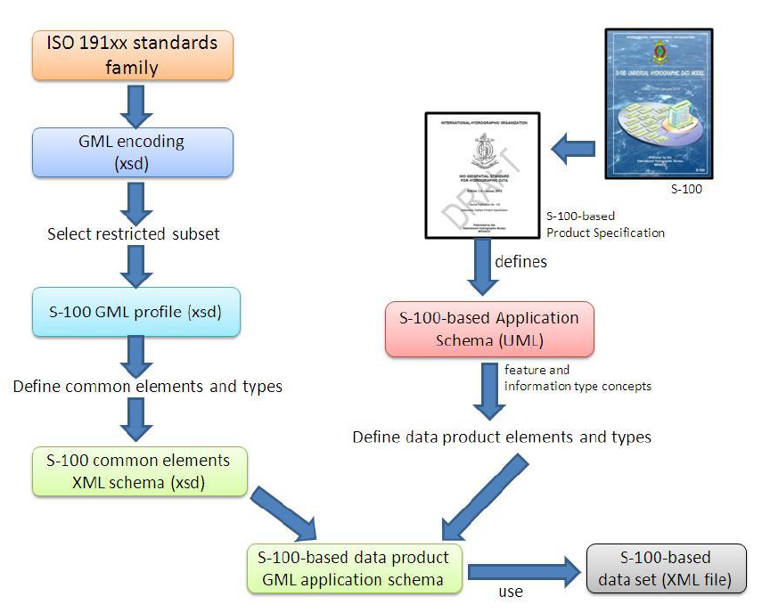

Figure 5‑2 - Derivation of the GML profile and its use by a data product

## **HDF5**

The Hierarchical Data Format 5 (HDF5) HDF has been developed by the HDFgroup as a file format for the transfer of data that is used for imagery and gridded data. HDF5 is particularly good at dealing with data where complexity and scalability are important. Data of virtually any type or size can be stored in HDF5, including complex data structures and data types.

S-100 Part-10c specifies a profile of HDF5 that is adopted for S-100. It specifies how to use HDF5 in a way that is compliant with the GFM and how to consistently specify the data formats for the types of coverages and point sets supported by S-100.



Figure 5‑3 Image showing (left side) the structure of the file and (right side) the two-dimensional compound array of values for regularly gridded data

## **Other encodings and encoding profiles**

Where the S-100 profiled encodings are not sufficient for the intended use of a Product Specification, a different encoding can be specified or profiled within the Product Specification. Sufficient detail should be given to permit implementers an easy understanding of the encoding chosen. A significant implication of this approach is that any system applications supporting the resulting data product may require bespoke development, which may be difficult in standardized equipment, such as ECDIS. An alternative is to request additional encoding profiles be added to S-100, which then can be added to systems that comply with S-100.

If other encodings are considered the best option for a Product Specification, the metadata must be correctly encoded to indicate that the Product Specification contains the encoding format for the data product. This is done using the Undefined value of the S100_DataFormat attribute in the discovery metadata of every compliant data product. See S-100 Part 4a for further details.

## **Application Schema**

Ideally, the full Application Schema is described in the Data content and structure section. It must be expressed in UML (S-100 clause 11-7.1), as described in S-100 Part 1, Conceptual Schema Language. The S-100 Product Specification Template stipulates that specifications that have large application schemas need contain only specific examples in UML in the specification document, since the Application Schema is realized in full in the Feature Catalogue. Because application schemas generally become too big to remain easily readable in one page, it may be beneficial for overall readability to split up the Application Schema into sections based on functions and elements. The elements used (for example all feature types in one diagram and all enumerated lists in another diagram) are discussed in section 2.2.9.2. Functions can be things like specific topics (for example how buoys are modelled; or how contact details are modelled) and how these are constructed.

## **Feature Catalogue**

ISO 19110 defines a Feature Catalogue as a catalogue that contains definitions and descriptions of the feature types, feature attributes, and feature associations occurring in one or more sets of geographic data. Therefore, the Feature Catalogue acts as a machine-readable representation of the Application Schema, and gives a system the means to describe the elements of a dataset that conforms to the Feature Catalogue.

When a data model is too big to be fully reproduced in UML within in a Product Specification, the Feature Catalogue in combination with specific subsets of the overall UML application schema can serve as a substitute to the requirement of full application schema being described in the product specification.

It is possible to create feature catalogues in a variation of ways, but it is recommended that it is done using the IHO Feature Catalogue Builder, as described in section 6.2. Feature catalogues created by other methods should be verified using the IHO Geospatial Information (GI) Registry, and then stored in the GI Registry Database in order to produce a Portrayal Catalogue using the IHO Portrayal Catalogue Builder.

## **Model elements used in a product specification**

This section is used for elaborating on the data modelling elements used in a Product Specification, such as in the Application Schema and Feature Catalogue parts. This is done to help readability of the document as a stand-alone document. For example, the Product Specification Template suggests that a specification include details of what types may be used and adapts the S-100 descriptions for increased readability. This method is given in the example below:

*Example:*

*Feature Types*

*<The following clauses describe the different feature types that may be used in the Feature Catalogue.>*

*Geographic*

*<Geographic (geo) feature types form the principle content of the dataset and are fully defined by their associated attributes and information types.>*

*Meta*

*<Meta features contain information about other features within a data set. Information defined by meta features override the default metadata values defined by the data set descriptive records. Meta features must be used to their maximum extent to reduce meta attribution on individual features.>*

*Feature Relationship*

*<A feature relationship links instances of one feature type with instances of the same or a different feature type. There are three common types of feature relationship: Association, Aggregation and Composition. >*

*Information Types*

*<Information types are identifiable pieces of information in a dataset that can be shared between other features. They have attributes but have no relationship to any geometry; information types may reference other information types.>*

Another simpler option for describing model elements used would be to simply reference the relevant sections of S-100, however a consequence of this approach is that the reader of the Product Specification needs to review S-100 for details. It should be noted that this approach might complicate the readability of the document instead of what would be the case were the definitions copied or paraphrased within the Product Specification.

An additional option to describe the model elements included in a Product Specification is to group elements according to some logical scheme, and then describe those groupings. This method allows a combination of the type description and at the same time links it with the usage within the specification. Figure 5‑4 below is an example of this method, describing all information types in a specific Product Specification.

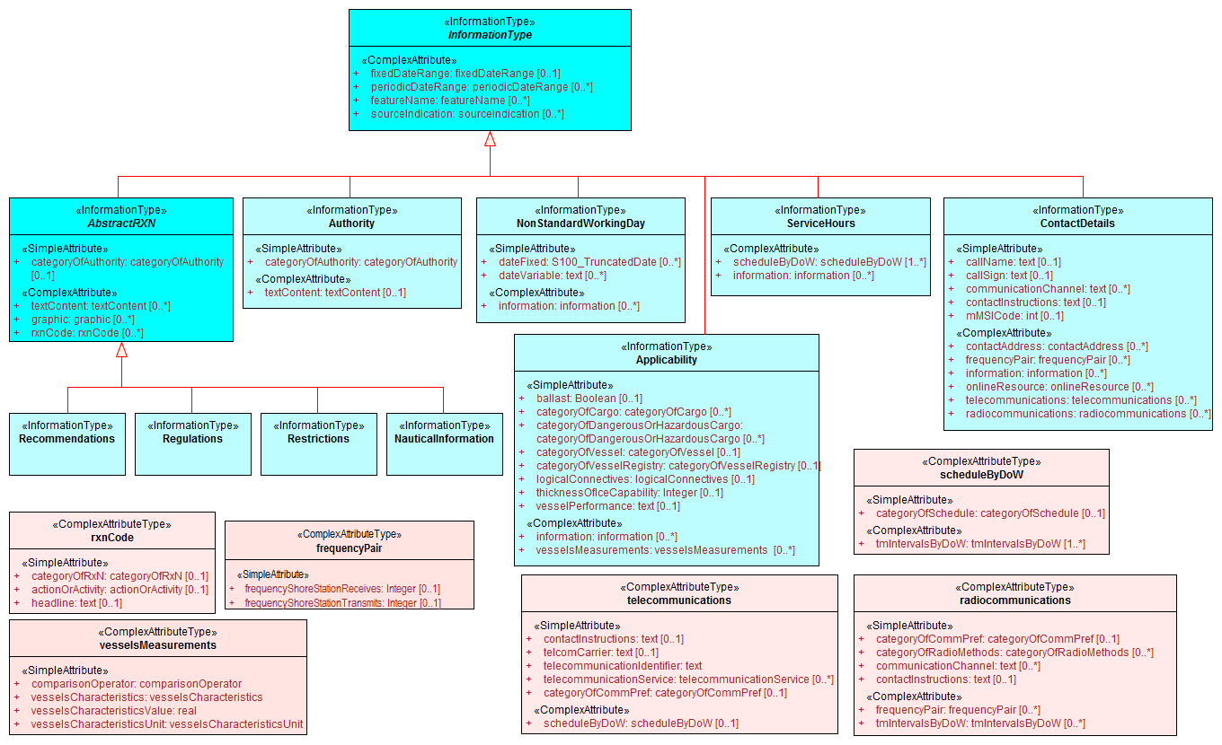

Figure 5‑4 - Example of an overview of S-Information Types, from S-123.

Ultimately the choice of how to best describe the Application Schema and the components that it consists of rests with the Product Specification developers.

## **Dataset types**

If the Product Specification uses datasets to bundle and exchange compliant information, there should be a description of all dataset types presented in this section. The description of the various types of datasets should include sufficient information for system implementers to know how to handle various types of datasets. For example a Product Specification that includes incremental updating of compliant datasets could describe the dataset types in the following way:

* Base dataset - the initial dataset containing all relevant data in an area.
* Revision dataset - Revision instructions to a previously published dataset; when implemented the dataset is considered updated.
* Re-issue - A dataset with all the revisions applied to the base dataset.

Any rules or specific characteristics that apply to datasets should also be described here. Rules could for example be a dataset size limit or specific data objects that need to be present for the dataset to be considered compliant with the Product Specification, such as a Coverage meta feature.

## **Dataset loading and unloading**

If the intended Product Specification has datasets that require a specific loading strategy, such as might apply if the datasets have multiple scales, this is described in this section. There should be sufficient details provided to give system implementers enough information to know how to create or load datasets in the correct manner. For example, any rules regarding dataset loading could be described using visual instructions like in Figure 5‑5.

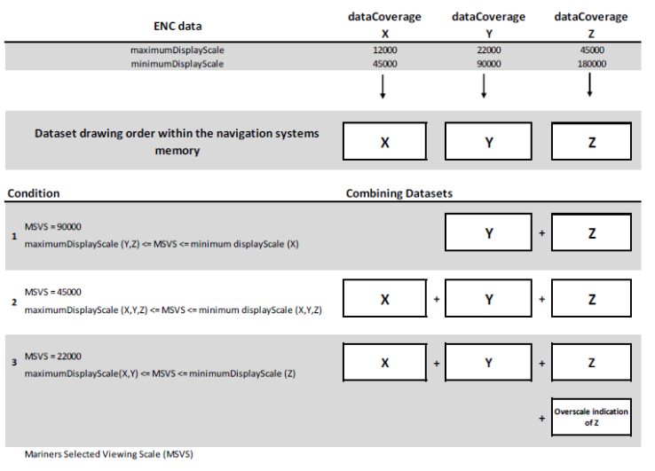

Figure 5‑5 - Example from S-101 data loading rules

## **Geometry**

A description of the geometry rules that apply in a Product Specification should be included to give system implementers sufficient details of the spatial model that is used in the data product. For vector data the description should include a specification of which S-100 Level of Geometry is used in the Product Specification, as well as any exceptions to the rules as stated in S-100 Part 7, clause 7-4.3. For coverage data there should be a description of which spatial model from S-100 Part 8 is utilized, such as what type of grid is used for gridded data. Any grid, point set or TIN structure rules and characteristics should be included, such as shown in the example in Table 5-3.

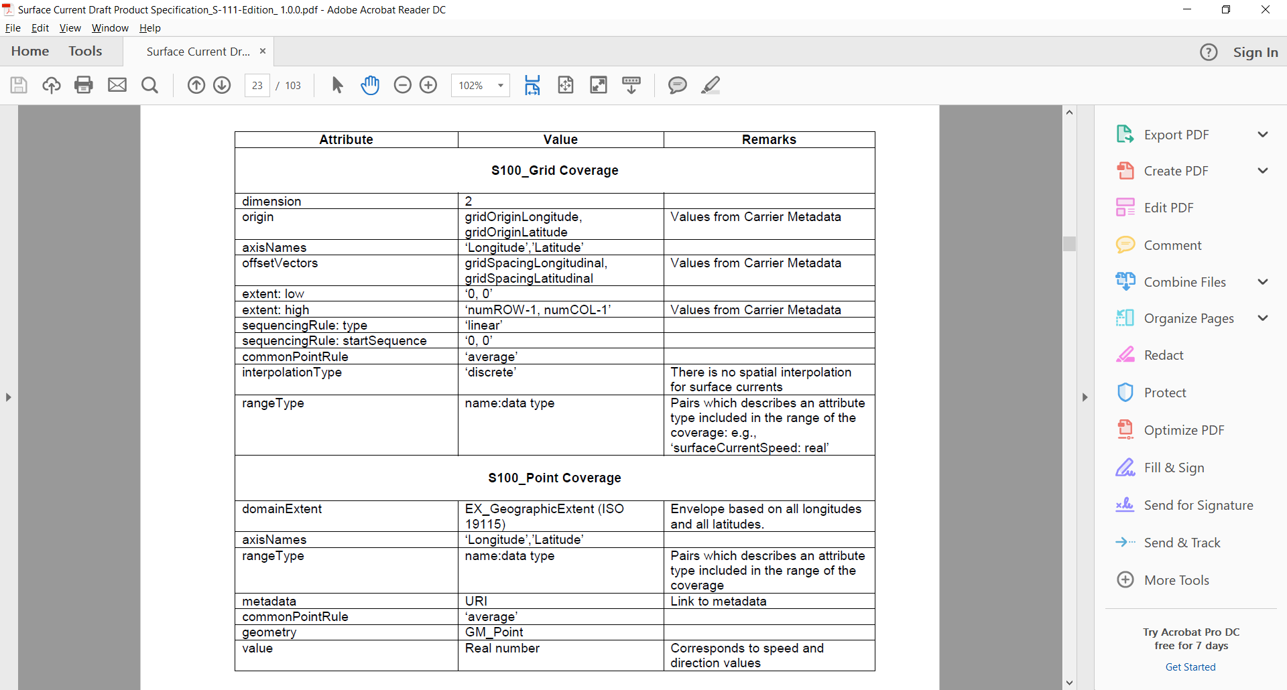

Table 5‑3 - Example of attributes and their values for S100_Grid Coverage and S100_Point Coverage.

## **Reference systems / CRS**

Product specifications must specify the reference systems that are to be used by the data products that result from the specification. All S-100 based product specifications that include georeferenced information will have a horizontal reference system, while vertical reference systems are for specifications that yield data products that include height information or bathymetry. A Product Specification may include more than one vertical reference system, such as one for sounding data and one for height data.

Two methods are available for how an S-100 based Product Specification should specify reference systems. These are to either specify the reference system used in full, or more commonly by referencing an already specified reference system. Part 6 of S-100 provides information of how to describe and specify a reference system. The more common method of simply referencing an already specified reference system is generally done by establishing a convention in the Product Specification by stating the reference system, or list of references systems used; and then by adding the information in the metadata of the resulting dataset. Figure 5‑6 below is an example from the S-100 Product Specification Template.

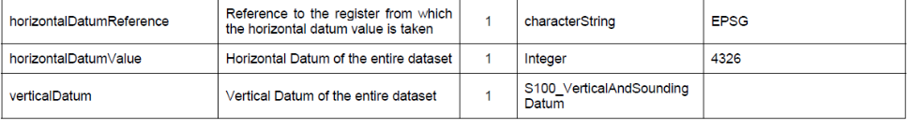

Figure 5‑6 Example of Reference Systems references

As noted in the example in Figure 5‑6, the EPSG Register is a useful Register of horizontal datums. The codelist value for WGS84, the most commonly used horizontal datum, is 4326. For vertical datums and sounding datums, S-100 includes an enumerated list named S100_VerticalAndSoundingDatum. The most commonly used vertical and sounding datums are included in this list. The enumerated list can be extended by requesting the IHO S-100WG to include additional values.

## **Object identifiers**

It is recommended that a Product Specification contain rules for persistent global identifiers for feature and information objects. Identifiers may be omitted where the physical realities dictate otherwise or it is known that a reference to the object will not be needed. For example, identifiers need not be defined for cartographic objects.

Identifiers of instances should utilize the Maritime Resource Name (MRN) concept and namespace. The MRN namespace is administered by International Association of Lighthouse Authorities (IALA) through the website <http://mrnregistry.org>, which also contain references to the full set of rules that apply to the MRN concept. The topmost namespace urn:mrn remains fixed, with subsequent name spaces separated by colons, and available through the application process explained on the website. Any organization wishing to issue MRN conformant identifiers should apply for a name space from IALA, or from an organization that already has a namespace registered, such as IHO. S-100 Part 11, Annex E contains additional details about the MRN concept.

Guidance should be included on persevering persistent global identifiers on objects throughout their lifecycle, including when they are reused in other products. Maintaining persistent global identifiers between products can help with interoperability and assist users and systems in identifying identical features between data products.

## **Data quality**

All S-100 based product specifications should include comprehensive ways of capturing information about the quality of the data that results from the specification. The data quality indicators are required for users and user systems to assess fitness for use of the data. Moreover, the data products may be used by user groups that it was not originally intended for, and with good quality indicators these secondary users can make better assessments of the data’s usefulness in their application.

There are several types of data quality elements that should be considered for any S-100 based product specifications, these elements include, but are not limited to:

* intended purpose of data;
* statement of quality or lineage;
* completeness of the data in terms of coverage;
* logical consistency;
* positional uncertainty and accuracy;
* temporal accuracy;
* thematic accuracy or completeness (areas of sparse data);
* anything specifically required for the specified product;
* validation checks or conformance checks, including:
  + - General S-100 tests;
    - General tests for dataset integrity;
    - Specific tests for a specific data model.

## **Data quality in the data**

Data quality is an important component when a user of the data determines the fitness for use of the data. Defining the data quality requirements for each scope of a Product Specification is a requirement. The IHO Data Quality Working Group (DQWG) and S-101 Project Team (S-101PT) has developed a data quality model for S-101 ENCs. This model has subsequently been used by various Working Groups and Product Specification development teams as a starting point for data quality in other domains. It can be helpful for new development to review the work of existing projects and product specifications in order to reuse all relevant parts of data quality models, instead of creating new models. This also helps with overall data harmonization within the e-Navigation eco system. Figure 5‑7 below shows the data quality model for S-101 ENC, but it should be noted that the model does not include the dataset level data quality metadata.

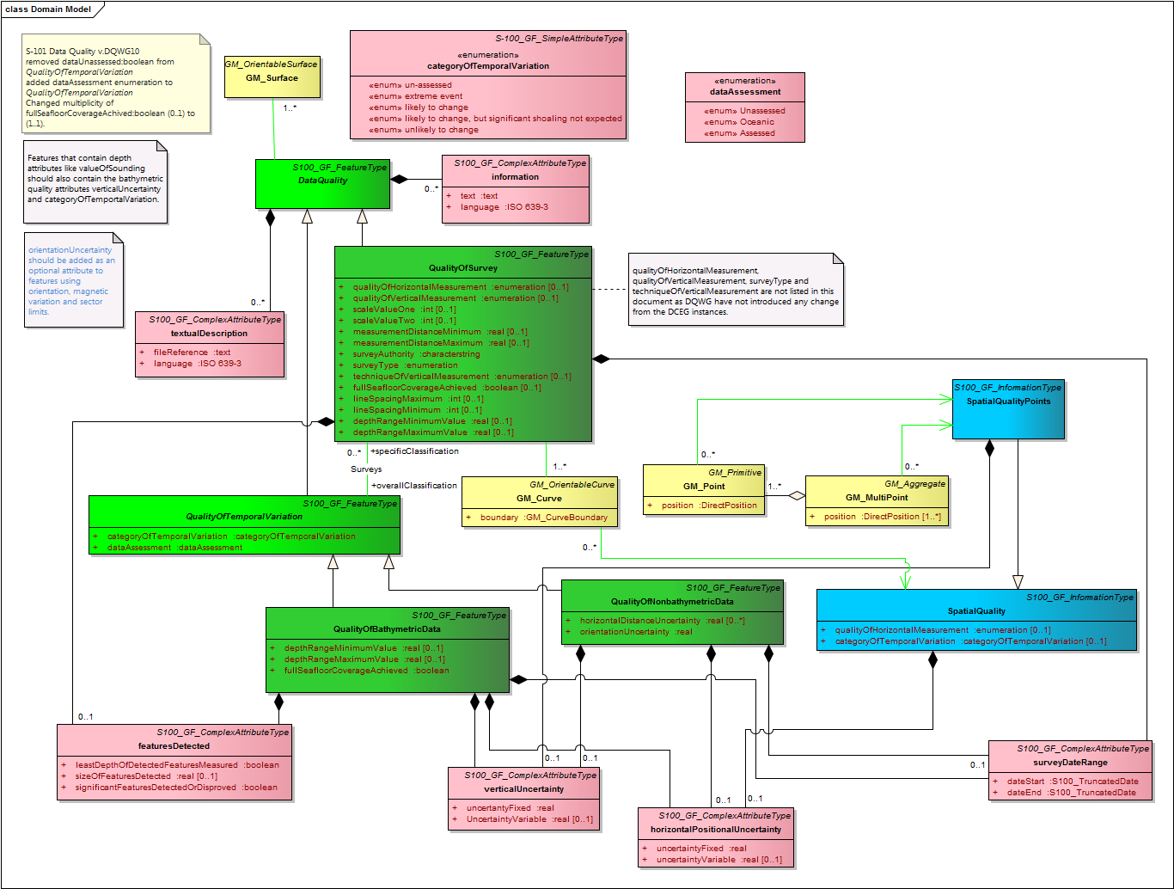

Figure 5‑7 - S-101 Data Quality model

The DQWG has created a Data Quality Checklist for Product Specification developers, which aims to ensure that data quality aspects are addressed in an appropriate and harmonized way for all S-100 based product specifications. This Data Quality Checklist provides recommendations of appropriate data quality measures for S-1xx based product specifications. The Checklist can be found in Part C of this Guideline.

When drafting a Product Specification, the Data Quality Checklist can serve as a guidance document to verify if the appropriate Data Quality Elements have been included in the Product Specification. A Data Quality Element is a quantitative component which documents the quality of a dataset. The applicability of a Data Quality Element to a dataset depends on both the dataset’s content and its Product Specification, the result being that all available data quality elements may not be applicable to all product specifications or datasets. It is left to the Product Specification developers to determine what data quality elements are appropriate.

## **Data quality checks**

It is recommended to develop conformance checks, or validation checks, for each Product Specification. These checks serve as a list of tests used to validate datasets conforming to the Product Specification. The checks should include tests for data format consistency, conformance to the specification and to the data model logical consistency. S-58 is the standard for validating S-57 ENCs and has been continually improved over almost 20 years of experience with S-57 production and use. S-58 can be used as a template for how to structure checks and it can provide input for which checks to consider when creating a new specification. It should be expected that the conformance checks will evolve as experience is gained with any Product Specification and they should therefore be considered a regular maintenance item.

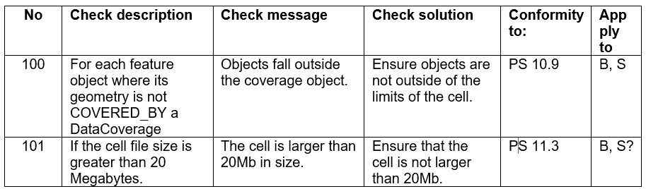

Figure 5‑8 Example of validation checks from draft S-122 v1.0.0

A set of generic S-100 validation checks are under development, and these should be considered for applicability to all S-100 based product specifications.

## **Data capture instructions**

Any S-100 based Product Specification must provide information on how data conforming to the Product Specification is to be captured. This information should be as detailed and specific as necessary. To this end, the S-100 Product Specification Template recommends the development of a Data Classification and Encoding Guide (DCEG). The DCEG is used to link practical examples to the data model. For example, the DCEG can explain how different types of underwater rock are to be encoded using a specific data model, including which feature class should be used; and what attributes; and their expected values that correspond to the different types of underwater rock. The DCEG template is a tabular representation of the Feature Catalogue with the option to include graphics and remarks specific for each feature class and information class. The tabular form includes the definition of each class; the attributes that the class carry; as well as descriptions of any associations the class may have.

The data capture guide is mostly used by the data producers and serves as collective instructional document of globally common rules of how to create data according to a specific Product Specification. The document will grow with experience as more special cases get resolved into a globally agreed process. This also improves overall consistency among producers and products, leading to more stable user systems as all stakeholders gain a common understanding of how to use the data products.

## **Maintenance**

Generally, it is expected that data created from an S-100 based Product Specification will not remain valid indefinitely. It is therefore necessary to specify how data created in accordance with a Product Specification shall be maintained, including how datasets and support files are updated.

Two main types of updating routines can be expected:

* As needed: This type of updating routine means that datasets are updated when there is a need to do so, and are to be considered the current information till there is a further update. Electronic Navigational Charts and Nautical Publications are two types of data that are generally maintained in this manner.
* By schedule: This type of updating routine means that datasets are updated on a fixed schedule or interval, and that users can always anticipate when new datasets become available. Surface current and water level information are two types of data that are generally maintained in this manner.

Once updating routines have been established for products created from a Product Specification, it is necessary to establish the means by which to achieve this. Again, there are mainly two options: incremental updates; and whole dataset replacement, both of which are elaborated in the next two sections.

It should be noted that these two types of updating are not mutually exclusive; and that combinations of the two can be utilized depending on the foreseen needs of the particular Product Specification. However, it is important to specify exactly how the updating methodology will work, to enable machine processing of new data.

Data Sources or events that may impact dataset maintenance are useful to elaborate in a Product Specification so that both producers and users can better understand what may cause new data to be issued.

## **Incremental update**

This type of updating is a method of updating a previously issued dataset by amending only a part of the dataset. This method can be very useful where bandwidth requires consideration and the changes are relatively minor within the scope of the whole dataset.

An example can be the addition of two objects to a dataset which contain thousands of other objects; the incremental update would then be a much smaller dataset that contains only the revision instructions to the main product data, or base dataset. Once the revision instructions are applied, the updated dataset would include the additional two objects. It may be required to retain both the base dataset and the incremental update within the user system for traceability purposes; and where this is the case, the specification should be written in a manner to explicitly state this for implementers.

It should be noted that with incremental updates there may come a point when there are so many changes that it makes sense to re-issue the dataset in a manner that includes all the changes applied previously via incremental update; thereby replacing the original base dataset with a new fully updated base dataset; and from there issue any changes as new incremental changes. In S-100 Edition 4, ISO 8211 and HDF5 encodings support this type of updating. GML encoding does not yet support this type of encoding.

## **Whole dataset update**

This type of updating is a method of updating a previously issued dataset by replacing it wholesale with a new dataset. This method makes most sense when the replacement data alters all or a sufficiently large portion of the previous dataset. For example, when forecasted data of a certain natural phenomenon is replaced with updated forecast data and the update data invalidates by being more current. All encodings in S-100 support this method of updating.

## **Support file maintenance**

Updating support files in S-100 based product specifications can be done through the metadata that goes with the support files. This is done by including issue date and management information in the discovery metadata file that is incorporated in the exchange set that includes the new or updated support file. Below is an example of how such instructions can be written for a Product Specification.

*Example:*

*The type of support file is indicated in the “purpose” field of the discovery metadata. Support files carrying the “deletion” flag must be removed from the system. When a feature pointing to a text, picture or application file is deleted or updated so that it no longer references the file, the system software must check to see whether any other feature references the same file, before that file is deleted.*

To avoid complex management routines, it may be advantageous to specify that each support file should only be used once in the exchange set and to store the support files in a separate folder within the exchange set.

## **Data product delivery**

The Product Specification may define the delivery medium (such as DVD or a web service) for each identified scope in the specification. This is an optional section, but it includes the structure of delivered data products, and is therefore of importance where data is delivered to systems that include a level of data import automation so as to allow implementers to program the system to a standardized delivery structure. It can also be useful to specify when data products can be delivered in different formats, such as SENC delivery. Data being delivered to ECDIS and similar systems generally expect exchange sets. S-100 includes a description of an S-100 exchange set for the interchange of geospatial data and its relevant metadata, and details can be found in S-100 Part 4a, Appendix D.

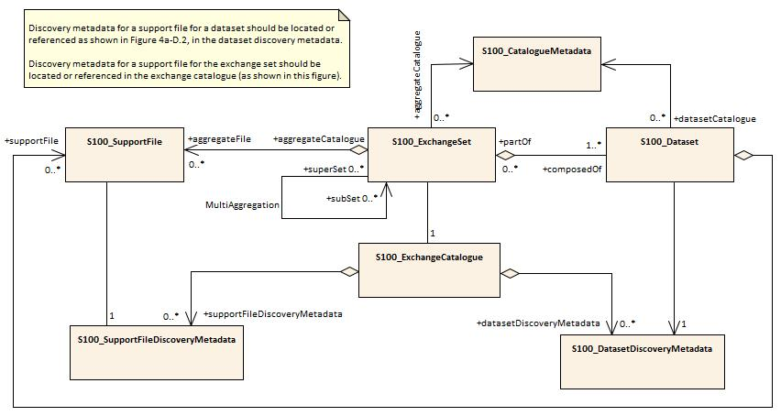

Figure 5‑9 - S-100 Exchange Set

Within an exchange set, several types of files are possible, in addition to the dataset. These types of files are generally named support files. The support files can be divided into two types; support files for the individual dataset and support files for the exchange set. Support files that are associated with the individual dataset usually include file types such as text files and image files; while support files that are associated with the exchange set, usually are feature and portrayal catalogues.

Depending on the target user, data products may be delivered in a variety of supply chain methods, such as via Regional ENC Coordinating Centre (RENC), service providers, web service, FTP etc. It can be useful to consider the supply chain when specifying the data product delivery.

## **Services and data streams**

S-100 includes an alternative distribution method called online data exchange, which is described in Part 14. This method can be used for a set of data or data which have a continuous nature. The latter is also known as “streaming data” and is used where the circumstances requires a more dynamic information flow to be available, such as monitoring of ship movement in a VTS setting.

Online data exchange between applications or devices can follow different communication patterns to support the variety of maritime operational needs. Multiple clients can interact with a service to interchange data which is modelled with S-100. It can be distinguished between unidirectional message streams like AIS and interactive information exchange like a web feature service (WFS). Context for a communication can be given by using the concept of session-oriented communication; which is when the communication between distinguished communication partners is assigned to a logical entity – a session. This permits metadata to be defined for the interactions assigned to the session.

The means of communication for the use of a service should be defined in a communication stack. Specifying a communication stack ensures that communication for the service is harmonized and makes implementation easier.

The communication is organized by a stack as defined by the ISO-OSI Reference Model:

* Session protocols (for example WSDL, SOAP, REST, SoS) to define message types;
* Encoding and compression (for example GML, XML, ISO 8211, HDF, ….) to serialize data;
* Communication protocol (for example HTTP) with encryption (for example HTTPS) to define interaction between gateways;
* Transportation Layer (for example TCP/IP) with encryption (for example SSL) to define the transportation node between gateways.



Figure 5‑10 - Communication Stack

S-100 Part 14 only addresses the concepts in the application and presentation layers. The lower layers are out of scope of S-100.

Product specifications that use the online exchange method must describe the concepts that are used to structure a session; and must explain how the data is transferred within sessions. A session-oriented service typically contains three components, each handling different types of data:

* Session component: Describing the handling of the session data (service request, service response, login, login response, logout).
* Service component: Describing the information to maintain the service (for example keep alive messages, service status).
* Data component: Describing the data itself; for example Vessel Traffic Image data (objects).

Any Metadata required for each component should be detailed in the Product Specification.

## **Dataset naming rules**

Dataset naming should follow a standard pattern to give implementers greater predictability of incoming datasets. All dataset naming conventions are recommended to follow these rules as much as possible.

XXXYYYYØØØØØØØØØ

XXX is the product code, for example 123 is for Maritime Radio Service; 101 for ENC.

YYYY is the producer code according to the Producer Code Register.

ØØØØ is an arbitrary length unique code in alphanumeric characters.

If useful, the Product Specification can include a differentiating character or code (for example the underscore (_) character) in the ‘ØØØØ’ space of the file name.

Support files should follow a similar naming.

## **Metadata**

Metadata is data about data. In S-100 the primary purposes of metadata are to provide information about the identification; spatial and temporal extent; quality; application schema; spatial reference system; and distribution of digital geographic data. It is applicable to the cataloguing of datasets, clearinghouse activities, and the full description of geographic and non-geographic resources.

Metadata can satisfy a number of uses: Data discovery; distribution and on-line references (URL) for on-line viewing; data use; details of data creation; data fitness; data sharing; data management; etc.

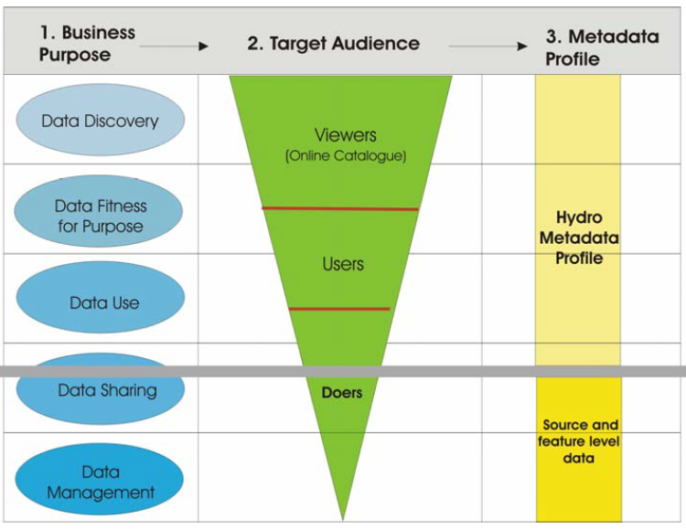

Figure 5‑11 - Example levels of metadata

S-100 Part 4 (Metadata) specifies the minimum metadata elements that must be included with a conformant data product. Moreover, S-100 requires that Discovery and Quality metadata shall be structured as per S-100 Parts 4a and 4c, respectively. Any additional metadata items required for a particular Product Specification must be documented in the data Product Specification, and these should be defined using ISO 19115-1 and ISO 19115-3, with extensions or restrictions if required. S-100 Part 4, Appendix 4a-E contains the rules that apply when extending or restricting the minimum metadata.

The Product Specification Application Schema shall specify how metadata is packaged in conformant datasets. This information shall be specified for each identified scope within the Product Specification. Furthermore, where the resulting data product is intended for a standardized user environment, like ECDIS, it should be noted that any significant deviation (for example addition or reduction to the standard metadata) may not be readily useable in the system depending on how the standard S-100 schemas have been implemented. Caution is therefore urged when developing the metadata for a Product Specification and it is highly recommended to stay within the S-100 metadata scope.

## **Discovery Metadata**

For information exchange, there are several categories of metadata required: Metadata about the overall exchange catalogue; metadata about each of the datasets contained in the catalogue; and metadata about the support files make up the package. These are called Discovery Metadata in S-100 and they are used within the exchange set to enable users to learn about the content without having to open each dataset or support file.

## **Discovery Metadata for datasets**

S-100 specifies that Discovery Metadata for datasets is contained within an external XML file created in accordance with the S-100 metadata schema. This metadata set complies with the minimum metadata and extends it in a few places to provide more details, for example about reference datums and issue dates of the data. More information about Discovery Metadata for datasets can be found in S-100 normative Appendix 4a-D, Discovery Metadata for Information Exchange Catalogues of.

## **Discovery Metadata for support files**

S-100 specifies that Discovery Metadata for support files is contained within an external XML file created in according with the S-100 metadata schema. This metadata set complies with the minimum metadata and extends it to provide information about the management of support files in order for them to be updated. More details can be found in the S-100 normative Appendix 4a-D, Discovery Metadata for Information Exchange Catalogues.

## **Metadata for streamed data and services**

Metadata for streamed data or services is also described in the S-100 normative Appendix 4a-D Discovery Metadata for Information Exchange Catalogues. S-100 Part 14 specifies additional and other metadata. As of Edition 4.0.0, the two have yet to be reconciled. Product Specification developers should, at this time, use the metadata from Part 14, and according to need, supplement with metadata from Part 4, including using the principles of metadata extension detailed in Part 4, Appendix 4a-E.

## **Portrayal**

Portrayal is an optional part of a Product Specification. However, if consistent portrayal across all user platforms is important to an S-100 based data product, then specifying how portrayal is done becomes mandatory. Within S-100 product specifications this is in part done by including a Portrayal Catalogue. The Portrayal Catalogue is a collection of defined portrayal instructions for a Feature Catalogue, and includes portrayal functions, symbols, and portrayal context.

Two types of portrayal catalogues are possible in S-100 – XSLT and LUA. Part 9 of S-100 provides instructions for how a Product Specification can include an input Schema derived from the abstract schema provided, a set of mapping rules (defined in XSLT or LUA), a set of symbols (defined in SVG format), line styles, colours etc.; and makes it available for use with product datasets. Portrayal catalogues can be created in a variety of ways, including manually and by using a Portrayal Catalogue Builder; see clause 6.4 for more details.

The IHO Hydrographic Standards and Services Committee (HSSC) has assigned the Nautical Cartography Working Group (NCWG) to assist with symbol design and colour selection for IHO product specifications. The NCWG chair can be contacted for further details.

Portrayal catalogues can for example be provided in an exchange set and may be combined with a Feature Catalogue and datasets. The exact method for distribution should be defined in the Product Specification, but considerations should be given to efficient distribution and aims of reducing data volume wherever possible. It may therefore be beneficial to consider some form of central distribution of portrayal catalogues.

The Product Specification should include instructions for implementers in the use of the Portrayal Catalogue, including context for the use of the data. Testbeds can be a good tool in learning what types of instruction is needed for implementers. Beyond testbeds, it can be expected that practical use will reveal additional issues that should be addressed in subsequent versions of a Product Specification.

Many of the IHO product specifications will be used in systems that have some degree of type approval requirements (for example ECDIS). Instructions for the classification society conducting the type approval should be added to product specifications where this is appropriate. These instructions should include guidance on tolerances for minor deviations and definitions of what constitutes a minor deviation.

## **Additional information**

The Product Specification should contain all information, at a sufficient level of detail, for easy implementation by the intended stakeholders. However, there may be additional considerations that impact implementers, users, and other stakeholders. These additional considerations can be added to a section or appendix called an Implementation Guide, or another appropriate title. Such a section can be used to give context of intended use, or used to elaborate on special circumstances that impact stakeholders, and so forth.

## **IHO S-100 infrastructure**

This section describes IHO Infrastructure that is being developed to support the S-100 framework and the e-Navigation concept.

## **GI Registry**

A Registry is the entire information system (or location) in which a collection of registers is located. A Register is a collection of tables in a database containing identifiers assigned to items with descriptions of the associated items. Descriptions may consist of many types of information, including names, definitions and codes.

In the case of S-100, the IHO is hosting an on-line registry engine called S-100 Geospatial Information (GI) Registry. It can be accessed here; <http://registry.iho.int>. This Registry provides the facility to access and maintain the various S-100 Registers. The S-100 GI Registry contains subordinate Registers.

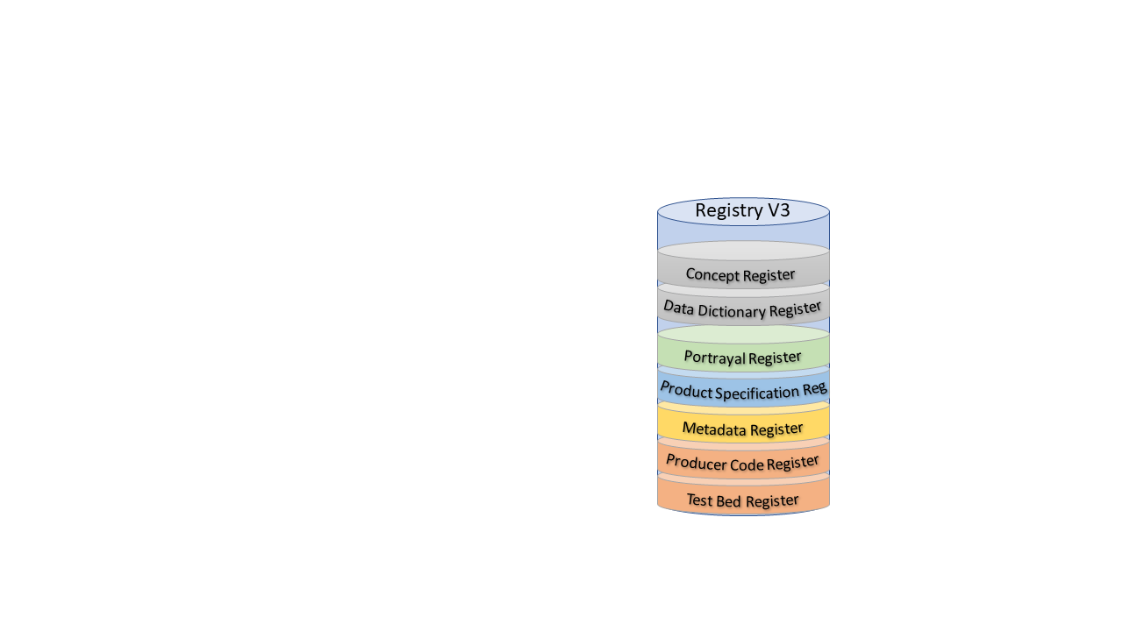

Figure 6‑1 - Registry (Version 3)

Each Register type can be further sub-divided into Domains, for example Hydrographic, Inland ENC, AtoN, etc. The administration of the Registry is governed by the IHO Publication S-99 – Operational Procedures for the Organization and Management of the S-100 Geospatial Information Registry.

A major benefit of the Registry and Register concept is its flexibility, which allows multiple versions of similar entries in the Concept Register using unique identification and classification. An entry is classified as being either:

* valid (latest version);
* superseded (previous versions);
* retired (no longer recommended for use); or
* not valid (proposed but not accepted or no longer acceptable).

Due to this classification and time stamps, a version of a Feature Catalogue references items that will always be legitimate even if a newer version of the referenced item is registered at a later date. This means that if a new item is registered or an existing item is amended, a new version of a Product Specification is not automatically required as a consequence. The category of “not valid” items is included in the Registers specifically to help identify the inappropriate reintroduction of previously rejected proposals.

## **Feature Catalogue Builder**

A Feature Catalogue is a machine-readable expression of the data model for a Product Specification. It can either be constructed with off-the-shelf XML editors or by a Feature Catalogue Builder (FCB). Either case must comply with the structure of S-100 Part 5 and the S-100 Feature Catalogue Schema. There is a FCB available from IHO for anyone wishing to utilize it in the creation of a Feature Catalogue for an S-100 based Product Specification. The software interacts with the IHO GI Registry and provides a mechanism for binding elements available in the Registry together to form features and attributes; enumerated lists with their available values; and so forth.

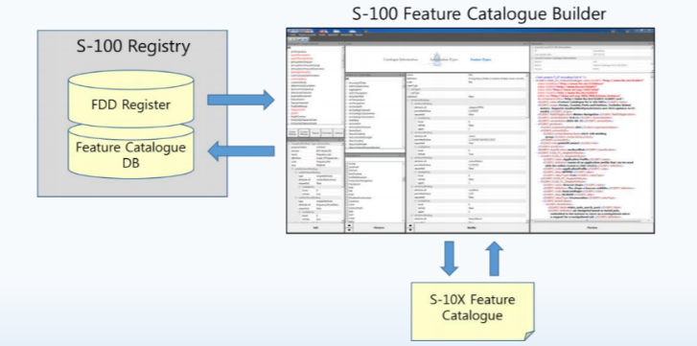

Figure 6‑2 - S-100 Feature Catalogue Builder

The FCB contains a function for working with proposals that have yet to be added to the Registry. This function provides a “sandbox” function by using an Excel spreadsheet in a specific format to carry proposed features, attributes, enumerate values, etc; and permitting the binding of these to entities from the Registry.

## **DCEG Builder**

To simplify the creating of the Data Classification and Encoding Guide (DCEG) for a Product Specification, a DCEG Builder has been created. This tool utilizes the Feature Catalogue to create the bindings and inputs for the DCEG tables. It is then a manual process to add images and specific text to the encoding part of the DCEG tables. Figure 6-3 below shows a high-level overview of the process to create a DCEG via the DCEG Builder. An Application Schema is required to make the Feature Catalogue, which equates to an XML representation of the Application Schema. The use of the Feature Catalogue can be described in the DCEG.

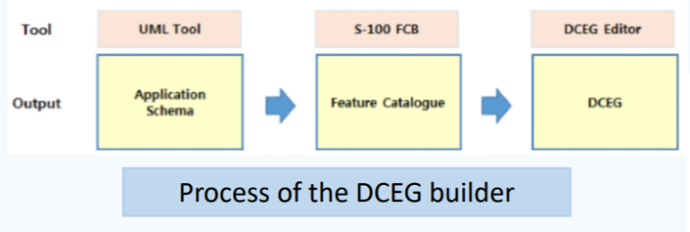

Figure 6‑3 - Process of creating a DCEG using the DCEG Builder

Use of the DCEG Builder is optional in the preparation of the Product Specification. Any S-100 based Product Specification must include sufficient instructions for how to encode information in a manner that conforms to the Specification, but these instructions do not have to follow a specific DCEG style. However, the DCEG style is simple to understand and by utilizing the DCEG builder, it is also easy to create tables[2] of feature and information types, attributes, associations and encoding instructions; and to ensure that these tables are consistent with the Feature Catalogue. The IHO-style feature tables (or equivalent) can be prepared and maintained using ordinary office word processing software, but experience shows that ensuring initial and continued conformance to the XML Feature Catalogue may be a significant task requiring much effort to maintain and keep current. Figure 6-4 below shows how the DCEG builder is connected to the GI Registry; and shows how the DCEG builder is integrated in the process of creating a Feature Catalogue. Using the Builder can greatly simplify the development process and increase consistency with the Feature Catalogue. It should be noted that the DCEG Builder is dependent on the Feature Catalogue being registered within the Feature Catalogue Database.

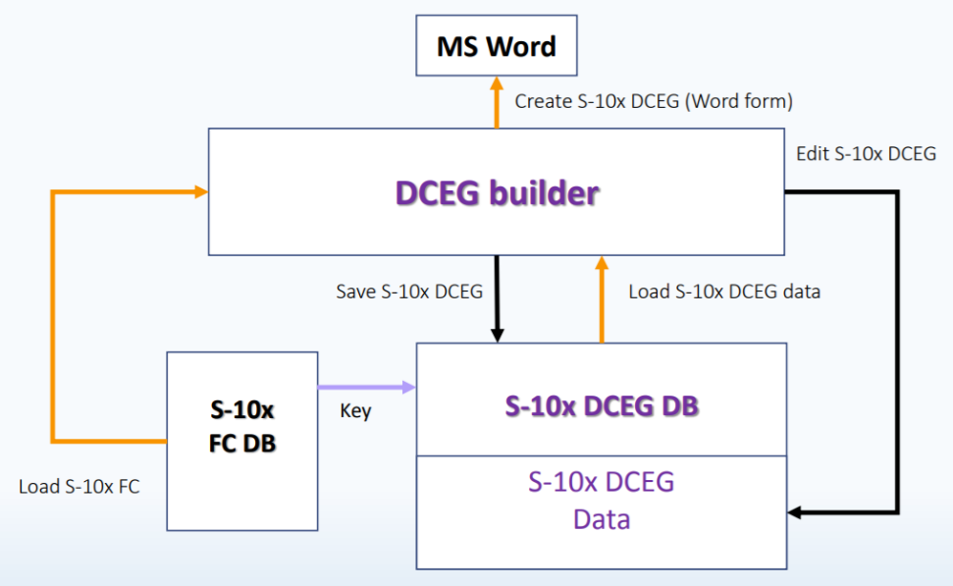

Figure 6-4 - DCEG Builder architecture

## **Portrayal Catalogue Builder**

Portrayal catalogues are machine-readable instructions for how to portray data compliant with a specific data model for a specific version of a Product Specification. They can either be constructed manually or by a Portrayal Catalogue Builder (PCB). In either case, they must comply with the structure specified in S-100 Part 9 and the S-100 Portrayal Catalogue Schema. The IHO infrastructure includes a PCB for XSLT for any Product Specification development team wishing to utilize it in the creation of a Portrayal Catalogue for an S-100 based Product Specification.

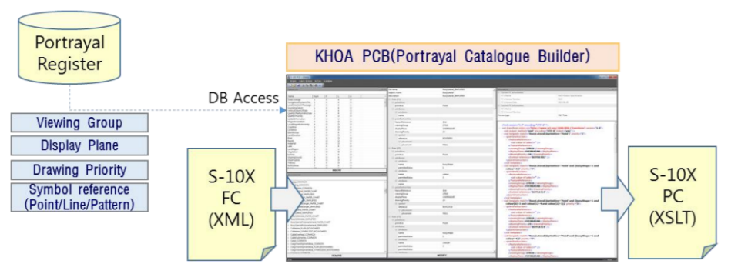

Figure 6‑5 - Portrayal Catalogue Builder

The software interacts with the Portrayal Register in the IHO GI Registry and the Feature Catalogue, and provides an interface for binding elements available in the registry together to form symbols, line styles and area patterns for the desired elements in the Feature Catalogue.

1. S-100 2a-4.2.3, specify ISO/IEC 646 (ASCII), while elsewhere 10646 (UTF-8) is used. Since it can be problematic to mix UTF-8 and ASCII, this guidance recommends to utilize only UTF-8.
2. A suggested format for such tables is described in the IHO S-100 Production Specification Template, which is referenced in S-100 Part 11, Appendix 11-D and available from the IHO web site.